______________________________________________________________________________
July 19, 2022
Mr. Neal Haddad
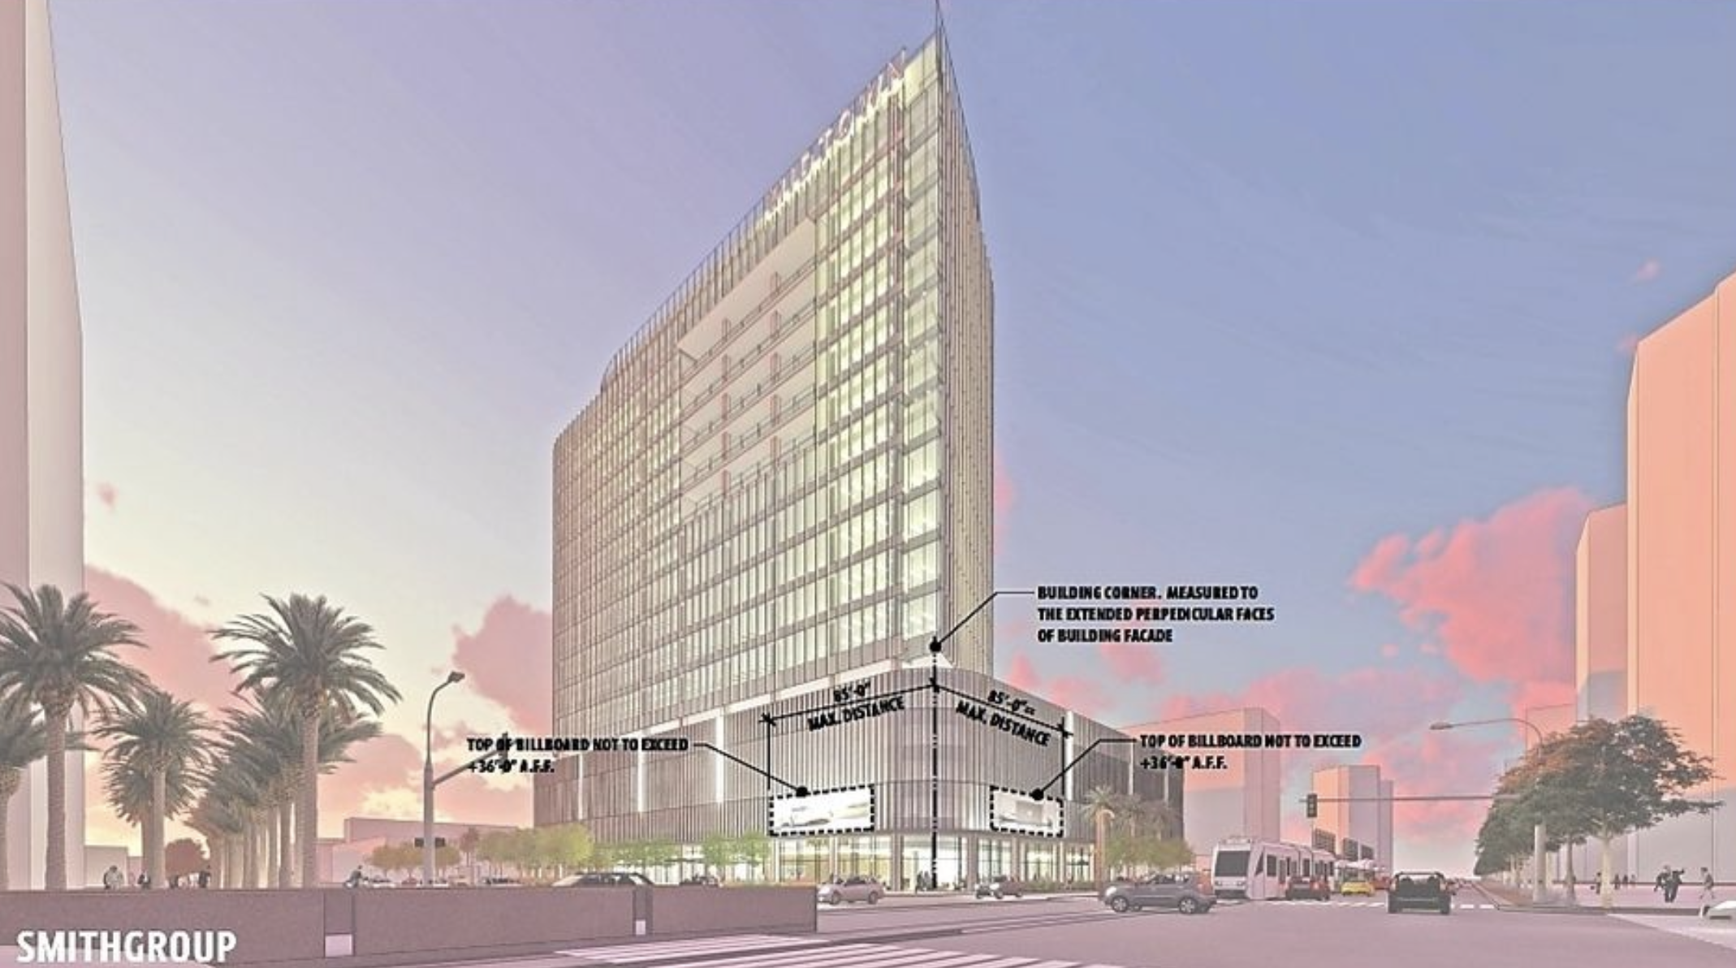
Mr. Paul Barnes

Dear Mr. Haddad and Mr. Barnes:

I appreciate your time in discussing the Willo Neighborhood Association’s continued and unwavering support for the Central and Thomas Project, as this project is critical to the ongoing development of the Central Park Corridor from Thomas Road northbound. It is disappointing to learn that the Arcadia-Osborn Neighborhood Association (AONA) board would not entertain our good-faith request to discuss the matter with the entire board in an open forum at your August meeting.

The Willo Neighborhood Conservation Plan mandates:
- Encouraging substantial development along Central Avenue
- Encouraging high-rise development
- Ensuring that the neighborhood shall be responsible for developing a partnership with the business community

I’m sure you appreciate that each neighborhood has historically had a right to self-determination and that respect should be paid to local residents’ preferences about what is best for their area. Arcadia-Osborn and Midtown Phoenix are two vastly different urban ecosystems. The Superior Court’s decision made it clear that, per statute and case law, you have no legal standing to interfere in a project more than five miles away from you – especially when the project has the enthusiastic approval of those living closest to it. We again request that you stop interfering in this project that is on Willo’s doorstep by dropping your appeal that has little chance of succeeding and instead focusing your efforts on projects that directly affect the Arcadia-Osborn neighborhood.

Sincerely,
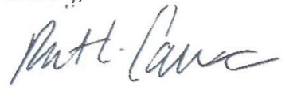
Dr. Robert L. Cannon, President
Willo Neighborhood Association
Presidential Member, Four Corners Leadership Group

Cc: Willo Board of Directors
Arcadia-Osborn Neighborhood Association (AONA) Board of Directors
Janelle Lowey (President), Neal Haddad (Vice President), Julie Jakubek (Treasurer),
Heidi Lane (Secretary), Lindsay Fricks (Director) Leslie Rachels (Director)

